**Designing and Building a Prototype of an Autonomous Robot System**

**Computer Science and Engineering**

**University of Rajshahi**



**Submitted By**

**Akhi Azim Papri**

**ID: 2112276104**

**Session: 2020 – 21**

**Date: 30.11.2023**

**Project Advisor**

**Prof. Dr. Bimal Kumar Pramanik**

**Table of Contents**

**Abstract…………………………………………………………………………………………………………...3**

**Introduction……………………………………………………………………………………………………..3**

**Methodology…………………………………………………………………………………………………….5**

**Proposed Design……………………………………………………………………………………………….7**

**Time Schedule…………………………………………………………………………………………………..9**

**Project Cost…………………………………………………………………………………………………….10**

**Conclusion………………………………………………………………………………………………………10**

**References………………………………………………………………………………………………………11**

**Abstract**

In an effort to promote sustainability and efficiency in educational environments, we propose the development of a Classroom Waste Collection Robot. This autonomous robot will be designed to navigate within a classroom, identify and collect various waste materials such as paper, unused pens, and other recyclables, and deposit them into designated bins outside the room. This project aligns with the goal of creating a cleaner and more eco-friendly classroom environment.

**Introduction**

**a. General Description**

A robot is a type of automated machine that can execute specific tasks with little or no human intervention and with speed and precision [1]. The Garbage Collection Robot is designed to collect solid waste at public places (schools, workplaces, and parks) and residential areas. The design of the robot is such that when it starts, it maneuvers as per programmed route [2].

This project holds the promise of revolutionizing waste management practices in educational settings, setting a precedent for the integration of technology to address everyday challenges. Through the Classroom Waste Collection Robot, we envision a cleaner, more efficient, and environmentally conscious learning environment, fostering a culture of responsibility and stewardship for generations to come.

**b. Background Study**

1. **Evolution of Robotics in Waste Management**

Robotics has been increasingly integrated into waste management systems to enhance efficiency and reduce human intervention. Automated robots have evolved to handle diverse tasks, from sorting recyclables to collecting and disposing of waste. The integration of robotics in waste management aligns with global efforts towards sustainable and smart solutions.

1. **Existing Autonomous Waste Collection Systems**

Several autonomous waste collection systems have been developed for various environments. Notable examples include street-cleaning robots and vacuum-based waste collection systems. However, there is a notable gap in the application of autonomous robots

Specifically designed for waste collection within confined indoor spaces, such as classrooms.

1. **Challenges in Classroom Waste Management**

Classrooms pose unique challenges for waste management due to the diverse types of waste generated, including paper, pens, and other materials. Traditional methods often rely on janitorial staff, leading to potential inefficiencies and delays. The need for a specialized robot designed for classroom environments arises from these challenges.

1. **Technological Components in Waste Collection Robots**

Successful waste collection robots incorporate a combination of sensors, machine learning, and efficient navigation systems. Sensors such as ultrasonic, infrared, and cameras enable the robot to detect obstacles and identify various materials. Machine learning algorithms enhance the robot's ability to distinguish between different waste items.

1. **Navigation Challenges in Confined Spaces**

Navigating within confined spaces, such as classrooms, requires advanced algorithms for obstacle avoidance and efficient path planning. The robot must be capable of maneuvering around desks, chairs, and other obstacles while ensuring timely and accurate waste collection.

1. **Human-Robot Interaction and User Interface**

The success of a classroom waste collection robot depends on seamless interaction with its human users. Developing a user-friendly interface, potentially through a mobile application, ensures easy scheduling, monitoring, and control. Effective human-robot interaction is critical for the robot's integration into educational settings

.

1. **Human-Robot Interaction and User Interface**

The success of a classroom waste collection robot depends on seamless interaction with its human users. Developing a user-friendly interface, potentially through a mobile application, ensures easy scheduling, monitoring, and control. Effective human-robot interaction is critical for the robot's integration into educational settings.

1. **Energy Efficiency and Sustainability in Robotics**

The choice of power sources greatly influences the sustainability of the robot. Exploring energy-efficient options, such as rechargeable batteries or renewable energy sources, not only reduces the environmental impact but also contributes to the overall sustainability goals

of the educational institution.

**Methodology**

1. **Requirements Analysis**

Conduct interviews and surveys with potential users (teachers, students, janitorial staff) to understand specific waste management needs within classrooms. Identify the types of waste materials commonly generated in classrooms.

1. **Review of Existing Systems**

Review existing literature on robotics in waste management, focusing on similar projects and technological advancements. Analyze successful case studies of autonomous robots operating in confined indoor spaces.

1. **System Design**

Define the overall architecture of the Classroom Waste Collection Robot, including hardware components (chassis, sensors, gripping mechanism) and software components (machine learning algorithms, navigation system). Establish communication protocols between the robot and the user interface.

1. **Hardware Development**

Design and build a durable and lightweight robot chassis that allows for efficient movement within a classroom. Integrate sensors (ultrasonic, infrared, cameras) to enable obstacle avoidance and waste material detection. Develop a versatile and reliable gripping mechanism for collecting various types of waste.

1. **Software Development**

Implement machine learning algorithms for waste material recognition based on image data. Develop a navigation algorithm that enables the robot to move seamlessly within a classroom, avoiding obstacles and reaching waste items efficiently. Create a user-friendly interface, potentially through a mobile application, for scheduling waste collection sessions and monitoring the robot's progress.

1. **Integration and Testing**

Integrate hardware and software components to create a functional prototype. Conduct rigorous testing in simulated environments to ensure the robot's reliability in waste identification, obstacle avoidance, and navigation. Iterate on the design based on testing results.

1. **User Interface Development**

Develop a mobile application for users to schedule waste collection sessions, monitor the robot's progress, and receive notifications. Implement manual control options in the user interface for users to intervene if needed.

1. **Energy Efficiency Measures**

Explore and implement energy-efficient solutions, such as rechargeable batteries or alternative power sources. Optimize the robot's power consumption to maximize operational efficiency.

1. **Documentation and Training**

Create comprehensive documentation for the Classroom Waste Collection Robot, including user manuals and maintenance guides. Provide training sessions for users and maintenance personnel.

1. **Pilot Testing**

Deploy the Classroom Waste Collection Robot in a real classroom environment for pilot testing. Gather user feedback and assess the robot's performance in a live setting.

1. **Optimization and Refinement**

Analyze pilot test results and identify areas for improvement. Refine the robot's design and functionality based on user feedback and performance data.

1. **Final Implementation**

Implement final modifications based on optimization and refinement. Prepare the Classroom Waste Collection Robot for full-scale deployment in educational institutions.

1. **Deployment and Monitoring**

Deploy the Classroom Waste Collection Robot in educational institutions. Establish a monitoring system to track the robot's performance and address any issues promptly.

1. **Evaluation and Reporting**

Conduct a comprehensive evaluation of the project, considering its impact on waste management efficiency and user satisfaction. Prepare a detailed report documenting the project's outcomes, challenges, and recommendations for future enhancements.

**Proposed Design**

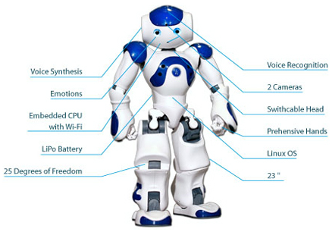

**Figure 1: Body parts of a robot [3].**

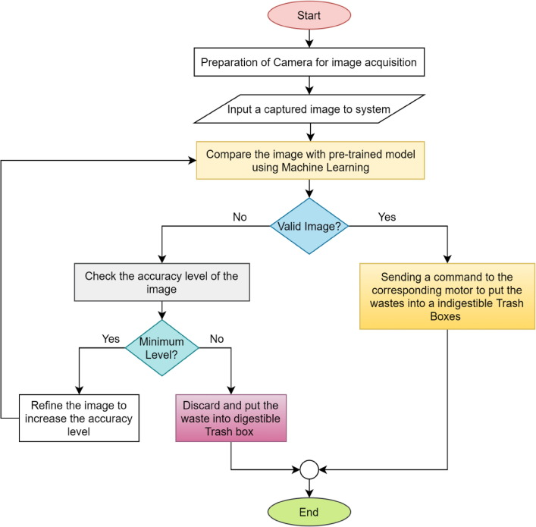

**Figure 2: Working steps of a waste collecting robot.**

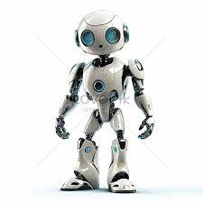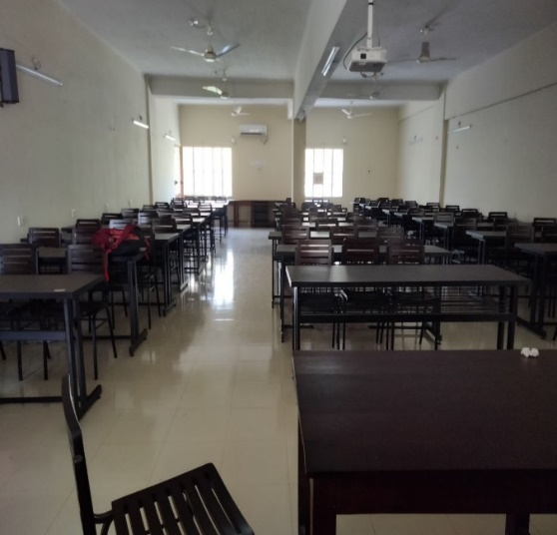





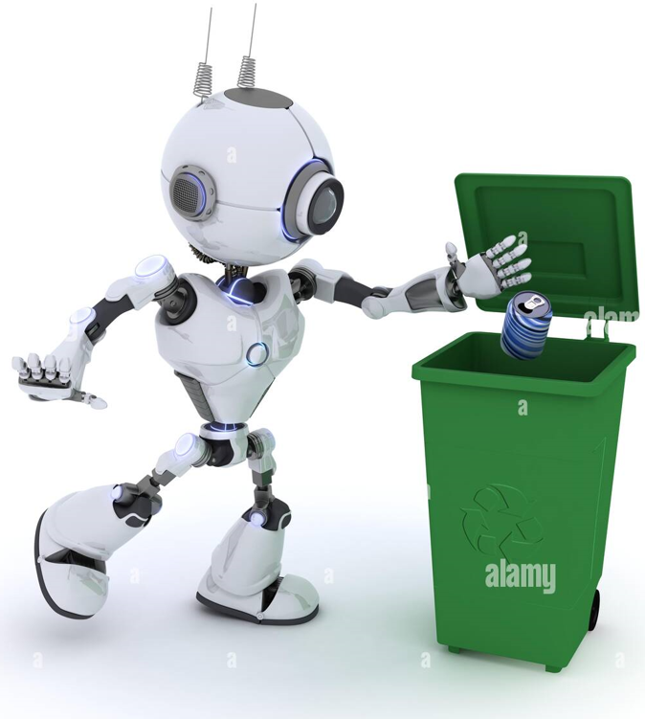

**Figure 3: Robot collecting wastes and put them into the bin.**

**Time Schedule**

A work schedule for the project is shown in the figure 2. The requirements analysis and review of existing systems will be done in the first week. The second, third and fourth week will be devoted to system design, hardware selecting and ordering from specific companies. Fifth week will be to assemble the design. Required software development will be completed between sixth to 10th weeks. Integration and testing, user interface development, energy efficiency measures, documentation and training, pilot testing, optimization and refinement will be carried out from 10th to the 14th weeks. Then the final implementation and deployment and monitoring will be held on the 14th and 15th week. Finally a report will be written and submitted in the 16th week.

**Table-1 (Time Schedule)**

|  |  |  |  |  |  |  |  |  |  |  |  |  |  |  |  |  |
| --- | --- | --- | --- | --- | --- | --- | --- | --- | --- | --- | --- | --- | --- | --- | --- | --- |
| **No. of weeks**  **Activity** | **w1** | **w2** | **w3** | **w4** | **w5** | **w6** | **w7** | **w8** | **w9** | **w10** | **w11** | **w12** | **w13** | **w14** | **w15** | **w16** |
| **Requirements Analysis** |  |  |  |  |  |  |  |  |  |  |  |  |  |  |  |  |
| **Review of Existing Systems** |  |  |  |  |  |  |  |  |  |  |  |  |  |  |  |  |
| **System Design** |  |  |  |  |  |  |  |  |  |  |  |  |  |  |  |  |
| **Hardware Development** |  |  |  |  |  |  |  |  |  |  |  |  |  |  |  |  |
| **Software Development** |  |  |  |  |  |  |  |  |  |  |  |  |  |  |  |  |
| **Integration and Testing** |  |  |  |  |  |  |  |  |  |  |  |  |  |  |  |  |
| **User Interface Development** |  |  |  |  |  |  |  |  |  |  |  |  |  |  |  |  |
| **Energy Efficiency Measures** |  |  |  |  |  |  |  |  |  |  |  |  |  |  |  |  |
| **Documentation and Training** |  |  |  |  |  |  |  |  |  |  |  |  |  |  |  |  |
| **Pilot Testing** |  |  |  |  |  |  |  |  |  |  |  |  |  |  |  |  |
| **Optimization and Refinement** |  |  |  |  |  |  |  |  |  |  |  |  |  |  |  |  |
| **Final Implementation** |  |  |  |  |  |  |  |  |  |  |  |  |  |  |  |  |
| **Deployment and Monitoring** |  |  |  |  |  |  |  |  |  |  |  |  |  |  |  |  |
| **Evaluation and Reporting** |  |  |  |  |  |  |  |  |  |  |  |  |  |  |  |  |

**Project Cost**

**Table-2 (Cost Estimation)**

|  |  |  |  |
| --- | --- | --- | --- |
| **Product No.** | **Product Name** | **Cost Per Unit(Taka)** | **Total Cost(Taka)** |
| 1. | Body Frame | 1,000 | 10,000 |
| 2. | Control System | 50,000 | 50,000 |
| 3. | Camera | 10,000 | 20,000 |
| 4. | Motor | 2,500 | 25,000 |
| 5. | Sensor | 1,500 | 15,000 |
| 6. | Reduction Gears | 1,000 | 5,000 |
| 7. | Battery | 25,000 | 25,000 |
| 8. | Worker Costs | 3,000 | 15,000 |
| **Total =** | | | **165,000** |

**Total Estimated cost will be =160,000 to 170,000 Taka.**

*Note: Hardware prices are collected from "Robotics BD Store" [4].

**Conclusion**

The development of the Classroom Waste Collection Robot marks a significant stride towards addressing the challenges posed by traditional waste management practices within educational institutions. As we conclude this project, it is evident that the integration of robotics and automation technologies offers a promising solution to enhance cleanliness, efficiency, and environmental responsibility in classroom environments. The implementation of the robotic system, featuring advanced sensors for obstacle detection, machine learning algorithms for waste material recognition, and an intuitive user interface, represents a leap towards creating smarter and more sustainable educational spaces.

**References**

[1] Hanshar, F. (2013). Pick and place robot. Dynamic vehicle routing using Genetic Algorithms

(2nd ed.). McGraw Hill

[2] Brown, T. (2011) "). Socially intelligent robots: dimensions of human-robot interaction. 11(2),

34-42.

[3] O'Meara, S. (2014) Orchid. Available at : www.theburrenorchidcollection.ie ( Accessed 3

February 2014 ).

[4] "Robotic BD Store", 2023

https://store.roboticsbd.com/